Project Proposal: Workflow for Analyzing the Quality of Hurricane Evacuation Routes

Brendan Sigale

GEOG:5055 Geospatial Programming

Spring 2021

# Goal

Hurricanes can cause immense damage and loss of life, caused by the sustained winds and massive flooding. Texas consistently has problems with their evacuation procedures, leading to gridlock on the designated interstates. This gridlock causes heat related deaths, starvation, and traps some in the areas which are about to be struck by the hurricane. It is also possible that impoverished areas are further from designated evacuation routes, allowing the affluent to escape the impending damage more easily. There may also be implications about racial bias which could be found through further analysis.

By creating a workflow which contains the tools for this analysis, users can analyze data for any evacuation routes and determine what insight can be gained by comparing it to census data. This analysis will look at Hurricane Harvey, which struck the Gulf Coast in 2017, as well as the CDC’s 2014 Social Vulnerability Index (SVI), which uses the CDC’s categories for addressing social vulnerability in census tracts. Some specific categories include age, English fluency, and housing statuses. Rankings are made based on percentile – thus, the closer a tract is to 1, the greater its vulnerability. This analysis will also include the USGS’s high water marks records and FEMA’s building damage, which could help identify a relationship between a tract’s SVI ranking and sustained damage.

# Specific Objectives

Some of the specific objectives this workflow will be able to answer (and will be answered in this analysis:

* Do census tracts which rank low on the SVI have better access to designated evacuation routes?
* Do census tracts which rank higher on the SVI flood more easily?
* Do census tracts which rank higher on the SVI sustain more building damage?

# Data Collection and Descriptive Statistics

* CDC Social Vulnerability Index
  + Shapefile polygons containing SVI’s data.
  + Contains Census data and CDC recorded metrics, including ranking, for all census tracts impacted by Hurricane Harvey. This includes tracts in Texas, Louisiana, Mississippi, Arkansas, and Alabama, totaling to 6,439 rows and 130 columns.
  + The top 10% are ranked as 1 and the bottom 10% are ranked as 0 to increase vulnerability of these tracts.
  + Tracts which do not have population data are ranked as -999, and will be removed from the data in the workflow.
  + Each census tract’s percentile is stored in the field ‘RPL_THEMES’
  + <https://www.hydroshare.org/resource/c2df2a80b9d6490788704a24854f4879/>
* Texas Evacuation Maps
  + Shapefile Polylines containing the route name, route type, shape length, and global ID.
  + Contains 164 Polylines, made up of Major Evacuation Roads, Potential EvacuLanes, and Potential Contraflow. EvacuLanes are areas which, when activated, allow the use of the road’s shoulder. Contraflow, when activated, reverses a road’s direction, transforming inbound lanes into outbound lanes.
  + The data contains 139 Major Evacuation Routes, 13 Potential EvacuLanes, and 12 Protential Contraflows.
  + <https://gis-txdot.opendata.arcgis.com/datasets/txdot-evacuation-routes?geometry=-117.399%2C26.556%2C-75.586%2C33.218>
* USGS Hurricane Harvey High Water Marks
  + Contains point data of recorded water peaks along the Texas Coast.
  + Contains 1,258 points and 43 fields.
  + Relevant field for analysis is peak_stage, which is the recorded water height.
  + The average peak_stage is 85.44, and the distribution skews heavily towards minimal values. That being said, there are still hundreds of values which are well above the mean, with the max being 453.8 feet.
  + <https://www.hydroshare.org/resource/615d426f70cc4346875c725b4b8fdc59/>
* FEMA Modeled Building Damage
  + Uses a FEMA Model to estimate building damage based on modeled inundation depth. This model was run on August 29, 2017. Given that hurricane Harvey had only hit four days earlier and flooding was still ongoing and growing, this model’s predictions may have been outdated by the time it was complete. Regardless, it provides a useful insight as to where building damage could be expected.
  + The dataset has 115,412 records and 23 columns.
  + The DMG_LEVEL column contains 57,111 records with ‘AFF’, 41,869 records with ‘MIN’, 12,140 records with ‘MAJ’, and 4,292 records with ‘DES’. While specific documentation is not available for these labels, it can be inferred that ‘AFF’ means ‘affected’, ‘MIN’ means ‘minor’, ‘MAJ’ means ‘major’, and ‘DES’ means ‘destroyed’.
  + <https://hub.arcgis.com/datasets/geoplatform::fema-modeled-building-damage-assessments-harvey-20170829?geometry=-106.129%2C27.389%2C-85.222%2C30.749&orderBy=DMG_TYPE>

# Proposed Workflow Models

Do census tracts which rank low on the SVI have better access to designated evacuation routes?

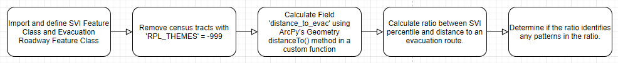

Do census tracts which rank higher on the SVI flood more easily?

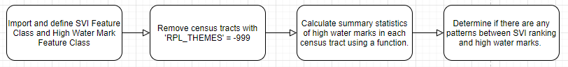

Do census tracts which rank higher on the SVI sustain more building damage?

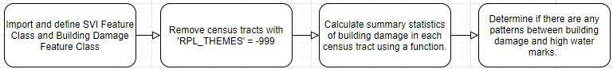

While these specific workflows are unique to these questions, the overall workflows would be the same regardless of what data was being input. The part which will be different depending on the use case is the third box in each workflow, which uses a custom function. These functions have not begun development, so there is no specific workflow as of now. However, they will accomplish the tasks set out in each box will be fully functional and generalizable to any supported datasets.

